1. Question:

Response:

How to Make a Peanut Butter and Jelly

1. Gather ingredients which as two butter knives, two slices of bread, peanut butter (crunchy or smooth), Jelly (strawberry, grape, or any flavor to your liking), a plate, and a napkin.
2. Then, place the two slices of bread on a plate.
3. Proceed to grab both knives, one for the peanut butter and the other for the jelly, to spread on each slice of bread.
4. Next, you will place both slices of bread together.
5. Finally, you eat your sandwich!

1. Question:

Response: In this example, we are able to to the previous steps to find an error until we can find what last worked properly.

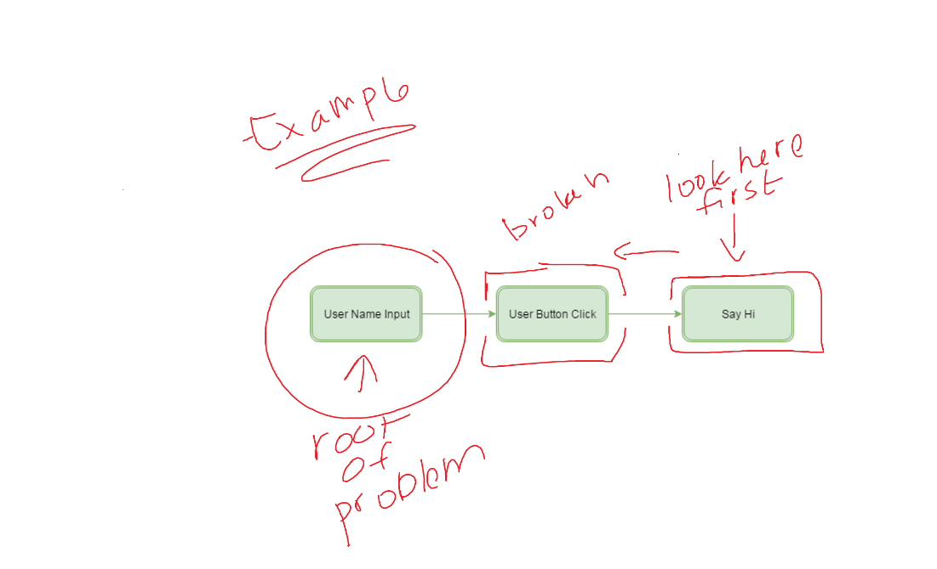

1. Response:

